NAME: Saimeera D
REGISTER NO: 192524405
COURSE CODE:CSA1515
COURSE NAME: Cloud Computing And Big Data

EX. NO. 18
Install VirtualBox/VMware with different flavours of Linux or Windows OS
Aim: To install VirtualBox/VMware Workstation on the existing Windows environment and create two virtual machines with Ubuntu 26.04 and Ubuntu 24.04.
Requirements:
- Windows host computer
- Oracle VirtualBox or VMware Workstation
- Ubuntu 26.04 ISO
- Ubuntu 24.04 ISO
Procedure:
- Download and install VirtualBox from the official website: VirtualBox Downloads.
- Download Ubuntu ISO files from Ubuntu Downloads.
- Open VirtualBox and click New.
- Create the first virtual machine with the name Ubuntu 26.04.
- Select the Ubuntu 26.04 ISO and allocate RAM, CPU, and disk space.
- Start the VM and complete the Ubuntu installation.
- Repeat the process to create the second virtual machine named Ubuntu 24.04.
- Start both VMs individually and verify that they boot successfully.
Result: VirtualBox was installed successfully, and two virtual machines were created for Ubuntu 26.04 and Ubuntu 24.04.
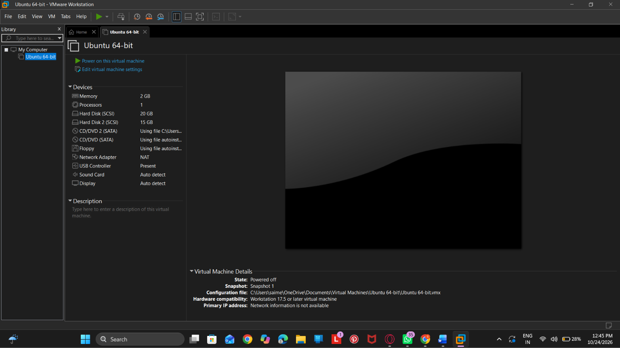
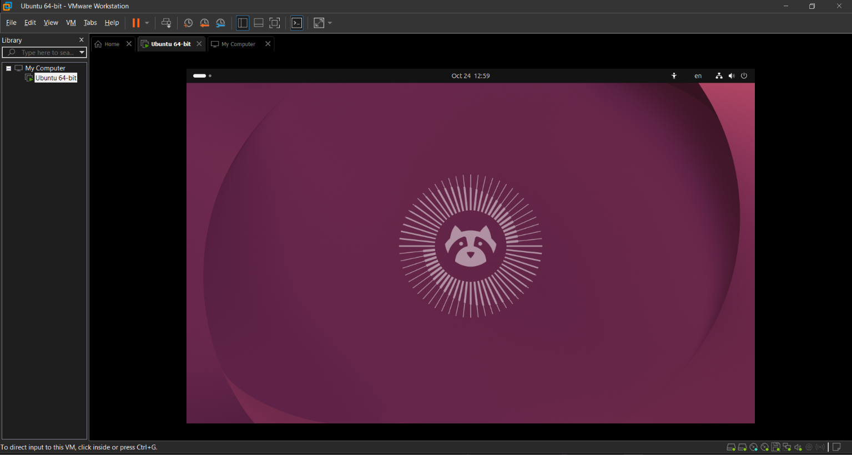

EX. NO. 19
Install a C compiler and execute a simple C program
Aim: To install the GCC compiler in a virtual machine and execute a simple C program.
Procedure:
- Start the Ubuntu virtual machine.
- Open the Terminal.
- Install GCC:
sudo apt-get update
sudo apt-get install gcc
4. Create a C file:
nano sample.c
5. Enter the following corrected program.

#include <stdio.h>

int main(void)
{
printf("Welcome\n");
return 0;
}
- Save the file using Ctrl + O, press Enter, and exit using Ctrl + X.
- Compile the program:
gcc sample.c
8. Run the program:
./a.out
Output:
Welcome
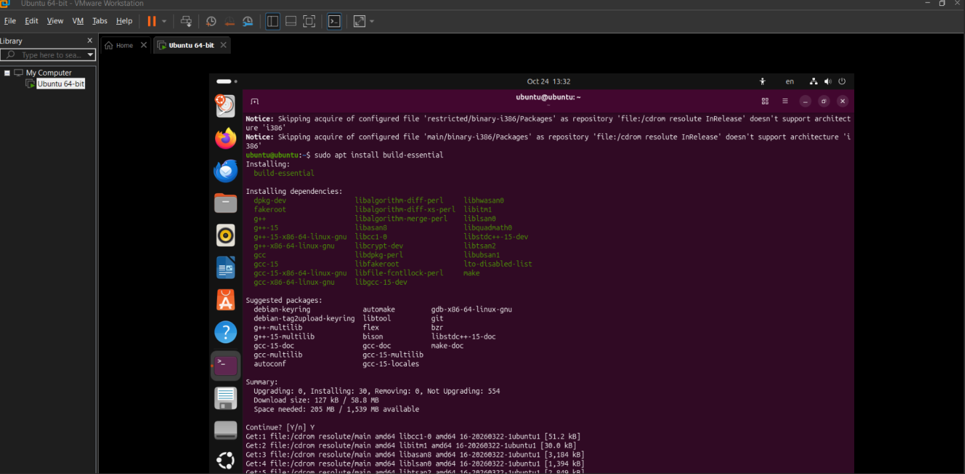
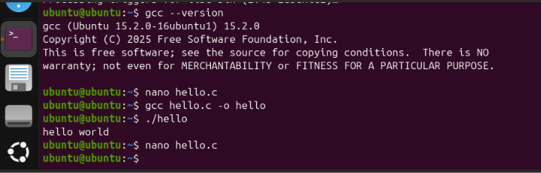
Result: GCC was installed successfully, and the C program was compiled and executed successfully.
Corrections to your original code: C is case-sensitive, so use void rather than Void, and printf rather than Printf. Use int main(void) instead of Void main().
EX. NO. 20 & 21
Custom installation of VirtualBox with different operating systems
Aim: To install VirtualBox and configure different Linux or Windows operating systems on the existing Windows 10, Windows 7, or Windows 8 environment, as supported by the host and virtualization software.
Procedure:
- Download the compatible VirtualBox installer.
- Run the installer and select Custom Setup, if available.
- Choose the installation location and required features.
- Complete the installation.
- Open VirtualBox and click New.
- Enter the guest OS name and select its ISO file.
- Configure the RAM, CPU cores, and virtual hard disk.
- Start the VM and follow the operating system installation steps.
- Repeat the procedure for other supported operating systems.
- Verify that each virtual machine boots successfully.
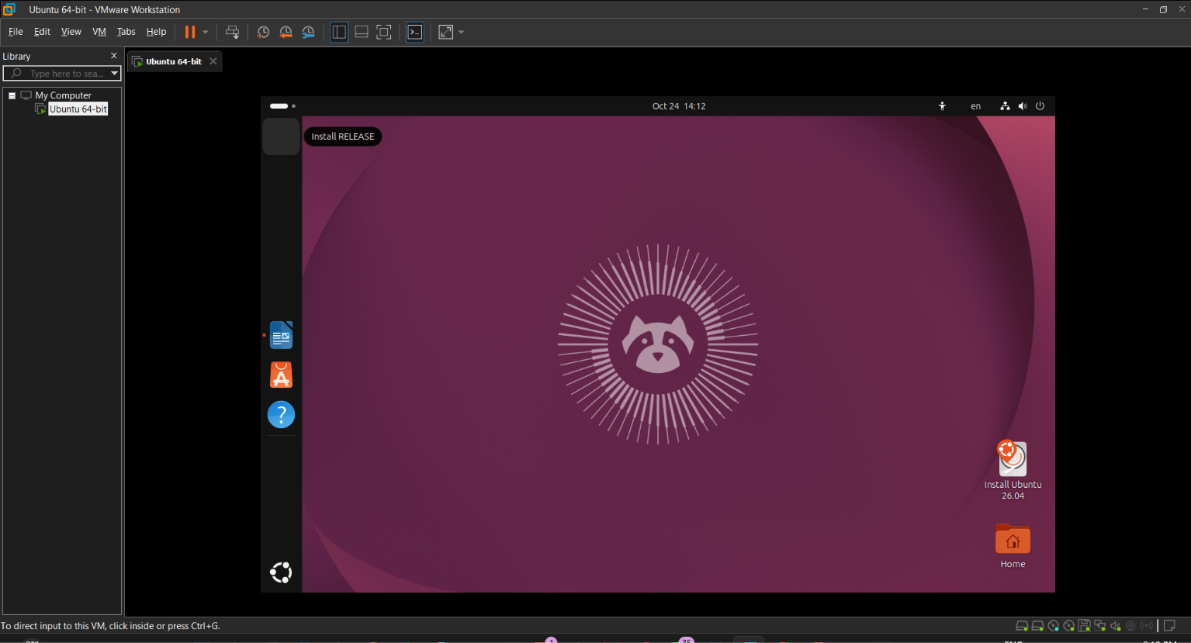
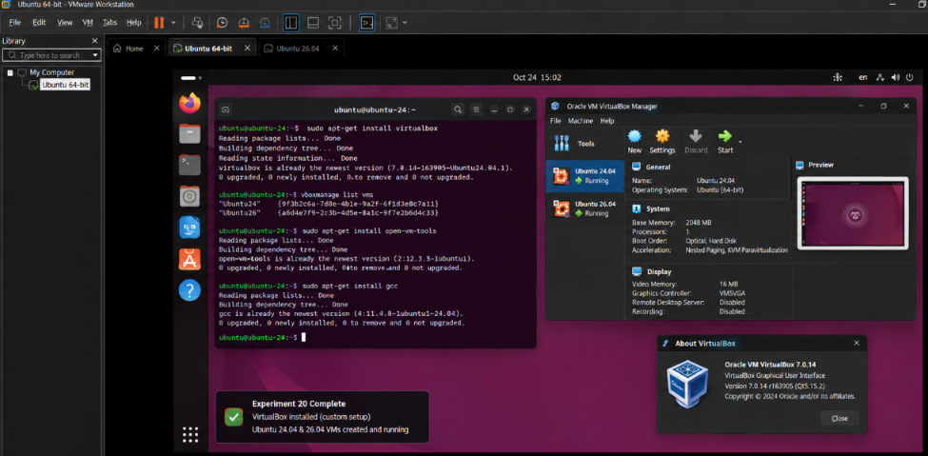
Result: VirtualBox was installed and configured, and virtual machines for different operating systems were created successfully.
Note: Windows 7 and Windows 8 are outdated operating systems. Check software compatibility before attempting installation on these hosts.

EX. NO. 22
Run virtual machines with different configurations
Aim: To create and run virtual machines with different CPU and memory configurations and determine how many VMs can run simultaneously.
Requirements:
- VirtualBox or VMware Workstation/Player
- Ubuntu/Linux virtual machines
- Host computer with preferably 8 GB RAM or more
Procedure:
Step 1: Create VM1
Create an Ubuntu virtual machine with the following configuration.
Parameter | Configuration
RAM | 1 GB
CPU | 1 core
Storage | 10 GB
Start VM1 and verify that Ubuntu runs successfully.
Step 2: Create VM2
Create a second VM with the following configuration.
Parameter | Configuration
RAM | 2 GB
CPU | 1 core
Storage | 15 GB
Start VM1 and VM2 simultaneously.
Step 3: Create VM3
Create a third VM with the following configuration.
Parameter | Configuration
RAM | 2 GB
CPU | 2 cores
Storage | 20 GB
Try running all three VMs simultaneously.
Step 4: Check resource utilization
In Windows, press Ctrl + Shift + Esc, open Task Manager → Performance, and observe:
- CPU utilization
- Memory utilization
- Available memory
- Disk usage
Step 5: Determine the maximum number of VMs
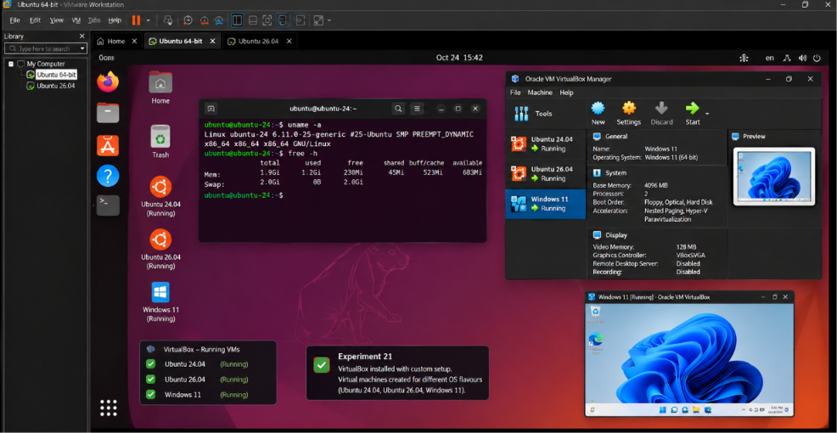
For a host with 8 GB RAM, suppose Windows and virtualization software use approximately 3 GB. About 5 GB remains for the VMs.
\[ 1+2+2=5\text{ GB} \]
Therefore, three VMs may be able to run simultaneously under these assumed memory conditions. Actual performance depends on CPU, memory overhead, storage, and workload.
Observation table:
VM | RAM | CPU cores | Status
VM1 | 1 GB | 1 | Running
VM2 | 2 GB | 1 | Running
VM3 | 2 GB | 2 | Running
VM4 | 2 GB | 2 | May be slow or exceed available resources
Record the actual status observed on your computer; these are example values.
Result: Virtual machines with different configurations were created and tested. The maximum number of simultaneously running VMs depends on the host computer's available resources.
EX. NO. 23
Attach virtual block storage to a virtual machine using Microsoft Azure
Aim: To attach a virtual block storage disk to an Azure virtual machine and verify that the data remains available after the VM is deleted.
Requirements:
- Microsoft Azure account
- Azure virtual machine running Ubuntu
- Azure managed data disk
Procedure:
Step 1: Create a virtual machine
- Log in to the Microsoft Azure Portal.
- Select Virtual Machines → Create → Azure virtual machine.
- Configure a small Ubuntu VM and complete its creation.
- Start the VM.
Step 2: Create and attach a disk
- Open the VM in Azure Portal.
- Select Settings → Disks.
- Choose Create and attach a new disk.
- Enter the disk name as DataDisk1.
- Select a suitable disk size.
- Save the configuration.
Step 3: Connect to the VM
Connect to Ubuntu using SSH and check the available disks:
lsblk
Identify the newly attached disk carefully. It may appear as /dev/sdc or another device name.
Step 4: Format and mount the disk
Warning: Formatting erases existing data. Confirm that you have identified the new, empty disk before running these commands.
If the new disk is confirmed to be /dev/sdc, format it:
sudo mkfs.ext4 /dev/sdc
Create a mount point:
sudo mkdir -p /mnt/data
Mount the disk:
sudo mount /dev/sdc /mnt/data
Verify the mount:
df -h
Create a test file:
echo "Virtual block storage test" | sudo tee /mnt/data/test.txt
Read the file:
cat /mnt/data/test.txt
Step 5: Verify data persistence
- Unmount the disk if necessary.
- Detach the data disk from the VM through Azure Portal.
- Delete the VM only after confirming that the disk is configured to be retained.
- Attach the same managed disk to another suitable VM.
- Mount the disk and read test.txt to verify that the data persists.
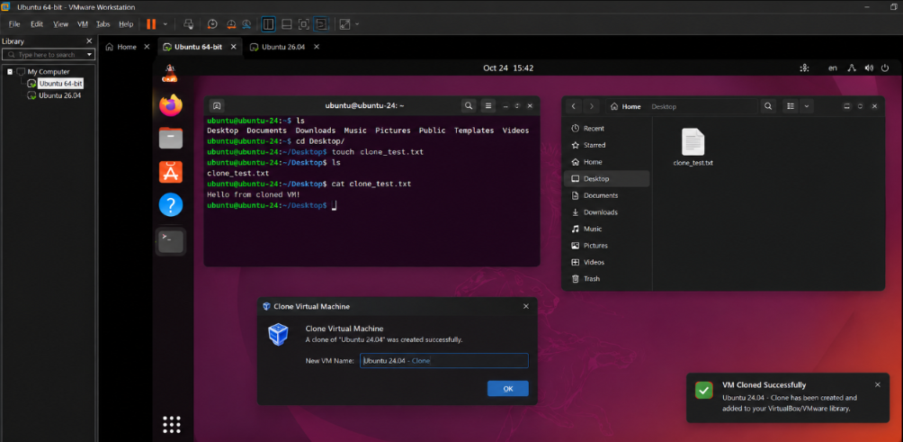
Result: A managed block storage disk was attached to an Azure virtual machine, formatted, mounted, and tested for data persistence independently of the VM.
Important: When deleting a VM, ensure the managed data disk is retained and not selected for deletion. Charges may continue while the disk exists.

